Waiting with Mary

Mary in Poetry

Daily Reflections for Advent 2019

After Annunciation

This is the irrational season
When love blooms bright and wild
Had Mary been filled with reason
There’d been no room for the child.

Madeleine L’Engle

On the following pages are 24 poems, one for each day in Advent 2019. We hope they provide you with a fresh look at Mary and her message for us today. As you read the poems, use the following questions to guide your reflection.

- How do you respond to the image or understanding of Mary and her message portrayed in the poem? What insights have you gained?

- When you receive shocking news, do you wait to see God at work?

- How do you wait when there is mystery, when you don’t understand what is going on?

- Who are your models for bearing God’s love to the world? Who gives you hope in the darkness?

- How will you wait this season? How are you called to bear love to the world?

Adapted from questions written by The Rev. Lauri Diamond, Pastoral Director and Missions Pastor at Redemption Anglican Church in Frisco, Texas and theologian Lindsey Paris-Lopez, editor-in-chief at the Raven Foundation.

Maria Sacerdota –
Mary, Protopriest of the New Covenant

Before Jesus
was his mother.

Before supper
in the upper room,
breakfast in the barn.

Before the Passover Feast,
a feeding trough.
And here, the altar
of earth, fair linens
of hay and seed.

Before his cry,
her cry.
Before his sweat
of blood,
her bleeding
and tears.
Before his offering,
hers.

Before the breaking
of bread and death,
the breaking of her
body in birth.
Before the offering
of the cup,
the offering of her
breast.
Before his blood,
her blood.
And by her body and blood
alone, his body and blood
and whole human being.

The wise ones knelt
to hear the woman’s word
in wonder.

Holding up her sacred child,
her God, in the form of a babe,
she said, “Receive and let
your hearts be healed
and your lives be filled
with Love, for
this is my body,
this is my blood.”

The Rev. Dr. Alla Renée Bozarth

Mosaic of the Nativity
Serbia, Winter 1993

On the domed ceiling God
is thinking:
I made them my joy,
and everything else I created
I made to bless them.
But see what they do!
I know their hearts
and arguments:

“We’re descended from
Cain. Evil is nothing new,
so what does it matter now
if we shell the infirmary,
and the well where the fearful
and rash alike must
come for water?”

God thinks Mary into being.
Suspended at the apogee
of the golden dome,
she curls in a brown pod,
and inside her the mind
of Christ, cloaked in blood,
lodges and begins to grow.

Jane Kenyon

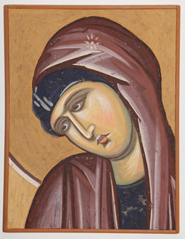
Mary, Detail from 14th C Serbian Fresco

Mary, Nazareth Girl

Mary,
Nazareth girl:
What did you know of ethereal beings
with messages from God?
What did you know of men
when you found yourself with child?
What did you know of babies,
you, barely out of childhood yourself?
God-chosen girl:
What did you know of God
that brought you to this stable
blessed among women?
Could it be that you had been ready
waiting
listening
for the footsteps
of an angel?
Could it be there are messages for us
if we have the faith to listen?

Ann Weems

Why the Image of a Starry Womb is Not Poetic Claptrap but Good Science

Once,
in a fit of romance,
I wrote of a woman:
“She wants to break, but not end,
to hold him through the night
and like all lovers,
become not salt or tears,
but stars.”

I threw it out;
it sounded too poetic.

Then I saw
the pregnant Virgin
contained in a rush
of seraphim wings, her blue mandorla
shot through
with starlight, shadow,
and a sober
quantum physicist
whispered in my ear, “each atom in your body
was once inside a star . . .”

I found the future
cradled
in this past:

called forth by stars
God calls by name –
This God who labors to give us birth –

we come,
as all things come,
to light.
Kathleen Norris

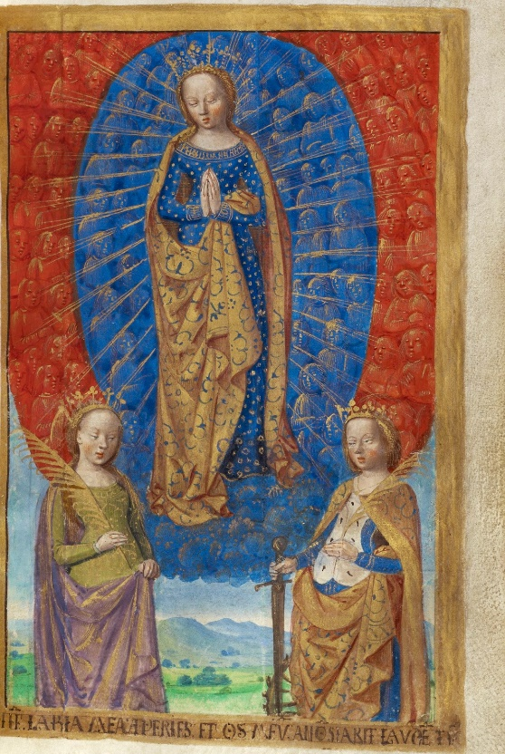
Virgin in Cloud of Angels with Saints Barbara & Catherine, The Porcher Hours

The Annunciation (Center Panel from the Mérode Altarpiece by Flemish Artist Robert Campin, Circa 1425-28)

An ordinary room with everyday
furniture, utensils, common floors and ceiling.
Mary is there. We see an open door.
As yet unseen by her, an angel kneeling
preludes the proclamation God has given.
The window blinds are partly open, where
billows of clouds are figured. From another
oval of aperture the Spirit’s seven
gifts penetrate to fill the future mother,
and we perceive the marriage of earth and heaven.
Luke 1:26-38

Thomas John Carlisle

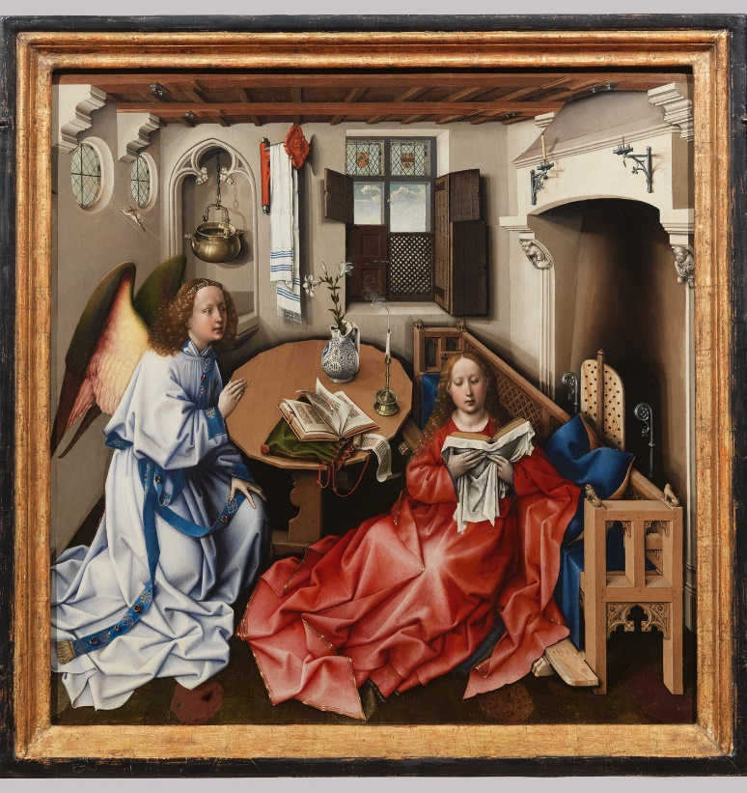
Annunciation Triptych (center panel), Workshop of Robert Campin

The Annunciation

Ashes of paper, ashes of a world
Wandering, when fire is done:
We argue with the drops of rain!

Until one comes Who walks unseen
Even in elements we have destroyed.
Deeper than any nerve
He enters flesh and bone.
Planting His truth, He puts our substance on.
Air, earth, and rain
Rework the frame that fire has ruined.
What was dead is waiting for His Flame.
Sparks of His Spirit spend their seeds, and hide
To grow like irises, born before summertime.
These blue things bud in Israel.

The girl prays by the bare wall
Between the lamp and the chair.
(Framed with an angel in our galleries
She has a richer painted room, sometimes a crown.
Yet seven pillars of obscurity
Build her to Wisdom's house, and Ark, and Tower.
She is the Secret of another Testament
She owns their manna in her jar.)

Fifteen years old -
The flowers printed on her dress
Cease moving in the middle of her prayer
When God, Who sends the messenger,
Meets His messenger in her Heart.
Her answer, between breath and breath,
Wrings from her innocence our Sacrament!
In her white body God becomes our Bread.

It is her tenderness
Heats the dead world like David on his bed.
Times that were too soon criminal
And never wanted to be normal
Evade the beast that has pursued
You, me and Adam out of Eden's wood.
Suddenly we find ourselves assembled
Cured and recollected under several green trees.

Her prudence wrestled with the Dove
To hide us in His cloud of steel and silver:
These are the mysteries of her Son.
And here my heart, a purchased outlaw,
Prays in her possession
Until her Jesus makes my heart
Smile like a flower in her blameless hand.

Thomas Merton

In the Kitchen
('In the sixth month the angel Gabriel...' Luke 1:26)

Bellini has it wrong,
I was not kneeling
on my satin cushion,
in a beam of light,
head slightly bent.

Painters always
skew the scene,
as though my life
were wrapped in silks,
in temple smells.

Actually, I had just
come back from the well,
placing the pitcher on the table
I bumped against the edge,
spilling water on the floor.

As I bent to wipe
it up, there was a light
against the kitchen wall,
as though someone had opened
the door to the sun.

Rag in hand,
hair across my face,
I turned to see
who was entering,
unannounced, unasked.

All I saw
was light
white against the timbers.
A voice I've never
heard greeted me,

said I was elected, would
bear a son who'd reign

forever. The spirit would
overshadow me.
I stood afraid.
Someone closed the door
and I dropped the rag.

Kilian McDonnell, OSB

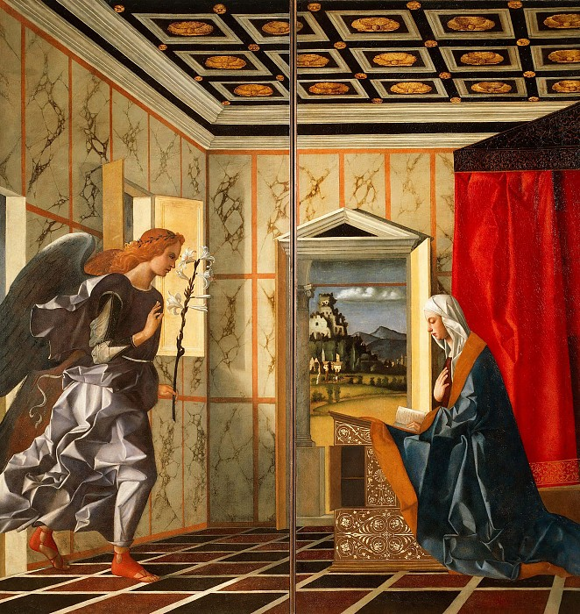
Annunciation, Giovanni Bellini

Annunciation

Sorrowfully
the angel appeared
before the young woman
feared
to ask what must be asked,
a task almost too great to bear.
With care,
mournfully,
the angel bare
the tidings of great joy,
and then
great grief.
Behold, thou shalt conceive.
Thou shalt bring forth a son.
This must be done.
There will be no reprieve.

2

Another boy
born of woman (who shall also grieve)
full of grace
and innocence
and no offence –
a lovely one
of pure and unmarked face.

3

How much can a woman bear?

4

Pain will endure for a night
but joy comes in the morning.

His name is Judas.

That the prophets may be fulfilled
he must play his part.
It must be done.
Pain will endure.
Joy comes in the morning.

Madeleine L’Engle

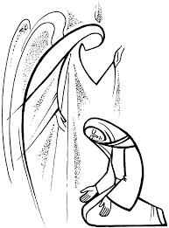

She Said Yeah (From Mysteries of the Incarnation)

The land lies open: summer fallow, hayfield, pasture. Folds of cloud mirror buttes knife-edged in shadow. One monk smears honey on his toast, another peels an orange.

A bell rings three times, the Angelus, bringing to mind Gabriel and Mary. “She said yeah,” the Rolling Stones sing from a car on the interstate. “She said yeah.” And the
bells pick it up now, saying it to Mechtild the barn cat, pregnant again; to Ephrem’s blue-birds down the draw; to the grazing cattle and the monks (virgins, some of them) eating silently before the sexy tongue of a hibiscus blossom at their refectory window. “She said yeah.” And then the angel left her.

Kathleen Norris

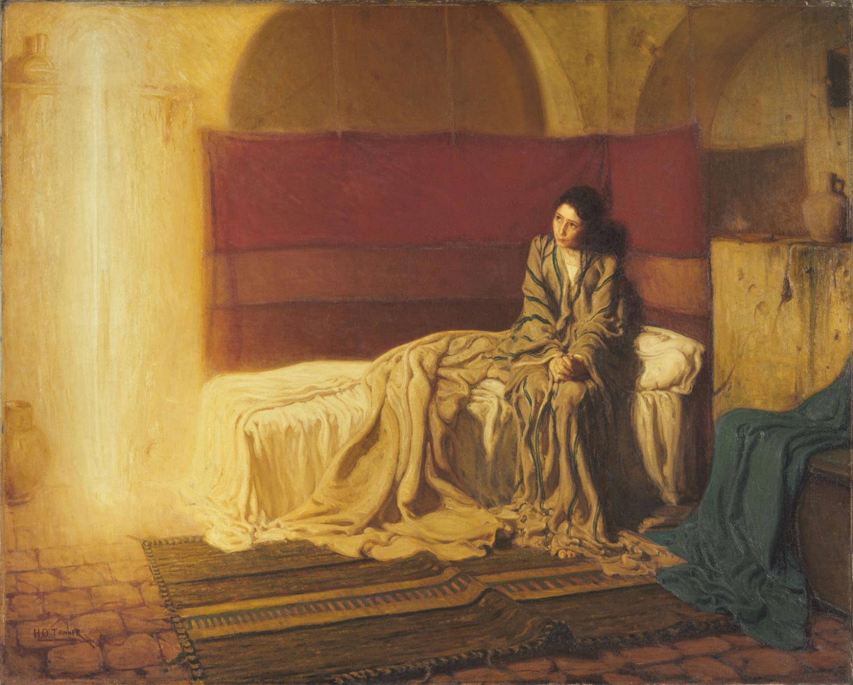
Annunciation, Henry Ossawa Tanner

From Three Songs of Mary

- O Simplicitas

An angel came to me
And I was unprepared
To be what God was using.
Mother I was to be.
A moment I despaired,
thought briefly of refusing.
The angel knew I heard.
According to God’s Word
I bowed to this strange choosing.

A palace should have been
the birthplace of a king
(I had no way of knowing).
We went to Bethlehem;
it was so strange a thing.
The wind was cold, and blowing,
my cloak was old, and thin.
They turned us from the inn;
the town was overflowing.

God’s Word, a child so small
who still must learn to speak
lay in humiliation.
Joseph stood, strong and tall.
The beasts were warm and meek
And moved with hesitation.
The child born in a stall?
I understood it: all
Kings come in adoration.

Perhaps it was absurd;
a stable set apart,
the sleepy cattle lowing;
and the incarnate Word
resting against my heart.
My joy was overflowing.
The shepherds came, adored
the folly of the Lord,
wiser than all men’s knowing.

Madeleine L’Engle

An Old Woman Remembers (Shame)

Pregnant before the bridal
bed, child carrying
child., knowing nods

as the village women see me
pass down the back
alley, whispers, sudden

silences at market as I reach
across the leeks for fresh
hard cucumbers from the country,

-- every choice signs away
tomorrow – teenage sideway
glances and giggles. Secret

awe at the unwed mother.
(How long had this been going
on?) No one sits beside me

on the bench in synagogue.
I see bags under Joseph’s
dark eyes. I’m alone.

Kilian McDonnell, OSB

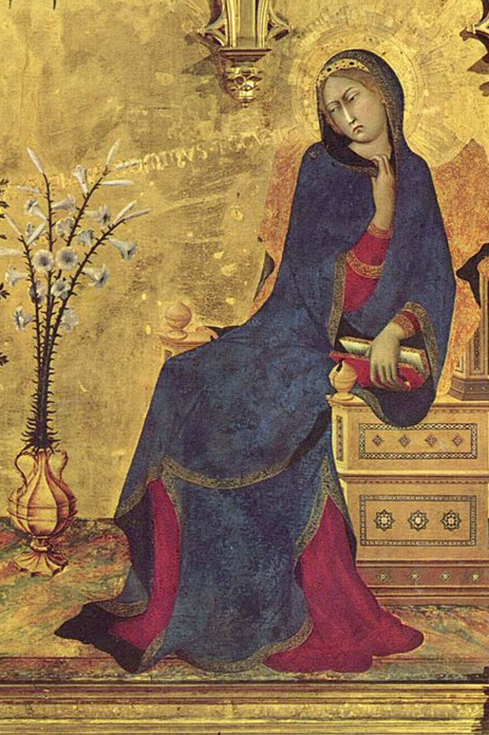
Annunciation (detail), Simone Martini & Lippo Memmi

The Visitation

She shared her feelings with Elizabeth
who recognized her coming as a sign
they two had been impressed into a role concordant with the grace of the divine
purpose and plan. Excitement filled their talk
as though each babe was calling to the other.
High dreams of Israel’s hope burst into song:
the joy, the mission granted to a mother.
Children to be prepared for great events
that those who bore them might not comprehend.
How much it meant to share the faith, the fear,
the anticipation with a trusted friend.
Luke 1:39-56

Thomas John Carlisle

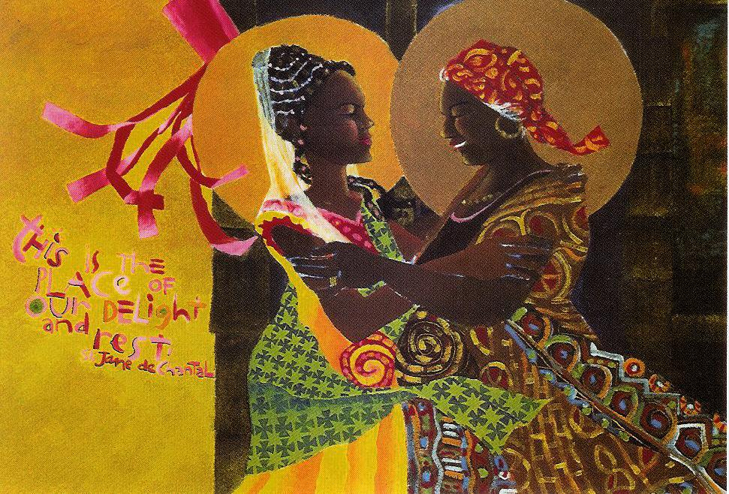
The Windsock Visitation, Mickey McGrath, OSFS

Magnificat

If Mary had sung
her song of songs
with our accustomed
unmagnificence
and dearth of urgency,
all the commitment
all the charm
and all the challenge
and anticipation
would have been
completely dissipated.

O sing anew
anew
anew
anew
the simple song
which magnifies
rejoices
dares to vision
the fall of kings,
the exaltation
Le magnificat, James Tissot
of the small
unviolent
trusting and faith-full
servants
of the spectacularly
creative God.
Luke 1:46-55

Thomas John Carlisle

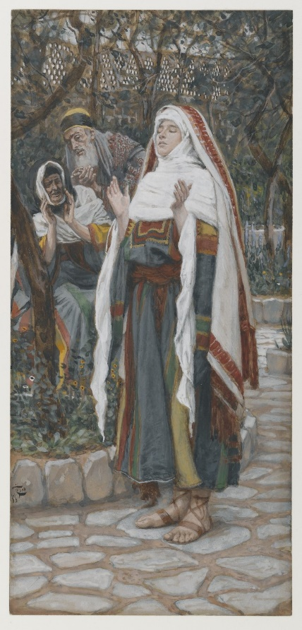

Mary’s Song: A Psalm for Every Woman

My soul celebrates Shaddai!¹

My spirit sings to Shekinah-Shaddai,²

for She erases my anonymity

so that all generations of women
are blessed.

She Who has power to open the womb
has done great things for me.

Holy is her name.

Her mercy flows
through mother to daughter

from generation to generation.

Her maternal strength
strikes at the roots of evil,
and it departs.

She pushes the proud
from the pinnacles of power
and lifts up little people.

She feeds her hungry daughters,

but those who are filled to the brim
with opportunity,
She sends away.

She soothes all those who turn to Her,
remembering Her compassion,

keeping Her promise to Sarah
and her progeny forever.

Miriam Therese Winter

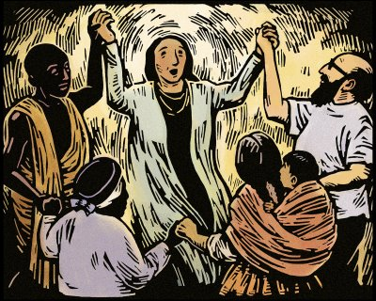
Mary’s Song, ©2008 Julie Lonneman

¹One of the Hebrew names for God, usually translated as God Almighty
²Feminine word meaning God’s presence on earth.

From Three Songs of Mary

- O Sapientia
It was from Joseph first I learned
of love. Like me he was dismayed.
How easily he could have turned
me from his house; but, unafraid,
he put me not away from him
(O God-sent angel, pray for him).
Thus through his love was Love obeyed.

The Child’s first cry came like a bell:
God’s Word aloud, God’s Word in deed.
The angel spoke: so it befell,
and Joseph with me in my need.
O Child whose father came from heaven,
to you another gift was given,
your earthly father chosen well.

With Joseph I was always warmed
and cherished. Even in the stable
I knew that I would not be harmed.
And, though above the angels swarmed,
man’s love it was that made me able
to bear God’s love, wild, formidable,
to bear God’s will, through me performed.

Madeleine L’Engle

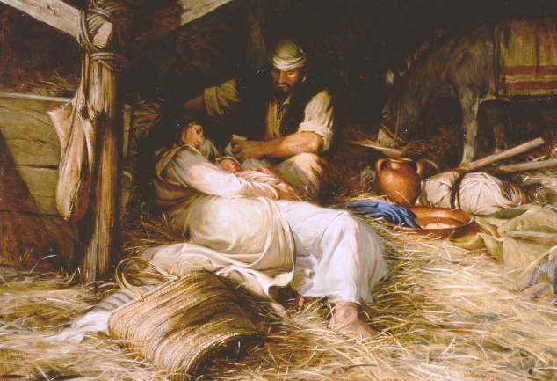
The Nativity, Walter Rane

Nativity

Immensity cloistered in thy dear womb,
Now leaves His well-belov'd imprisonment,
There He hath made Himself to His intent
Weak enough, now into the world to come;
But O, for thee, for Him, hath the inn no room?
Yet lay Him in this stall, and from the Orient,
Stars and wise men will travel to prevent
The effect of Herod's jealous general doom.
Seest thou, my soul, with thy faith's eyes, how He
Which fills all place, yet none holds Him, doth lie?
Was not His pity towards thee wondrous high,
That would have need to be pitied by thee?
Kiss Him, and with Him into Egypt go,
With His kind mother, who partakes thy woe.

John Donne

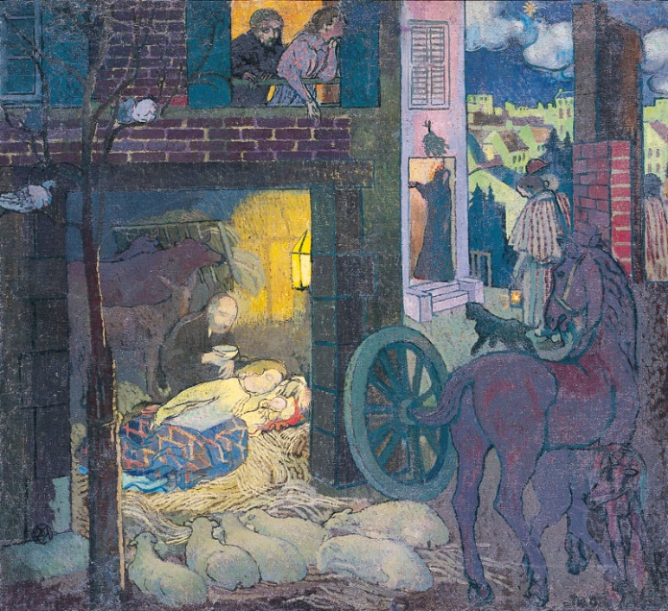
Nativité, Maurice Denis
An Old Woman Remembers (Bethlehem)

Eight months gone, I ride
donkey, Joseph walks
ninety miles to Bethlehem.

Our cave is cold and damp,
oxen stamp their feet
at the invasion, two nervous
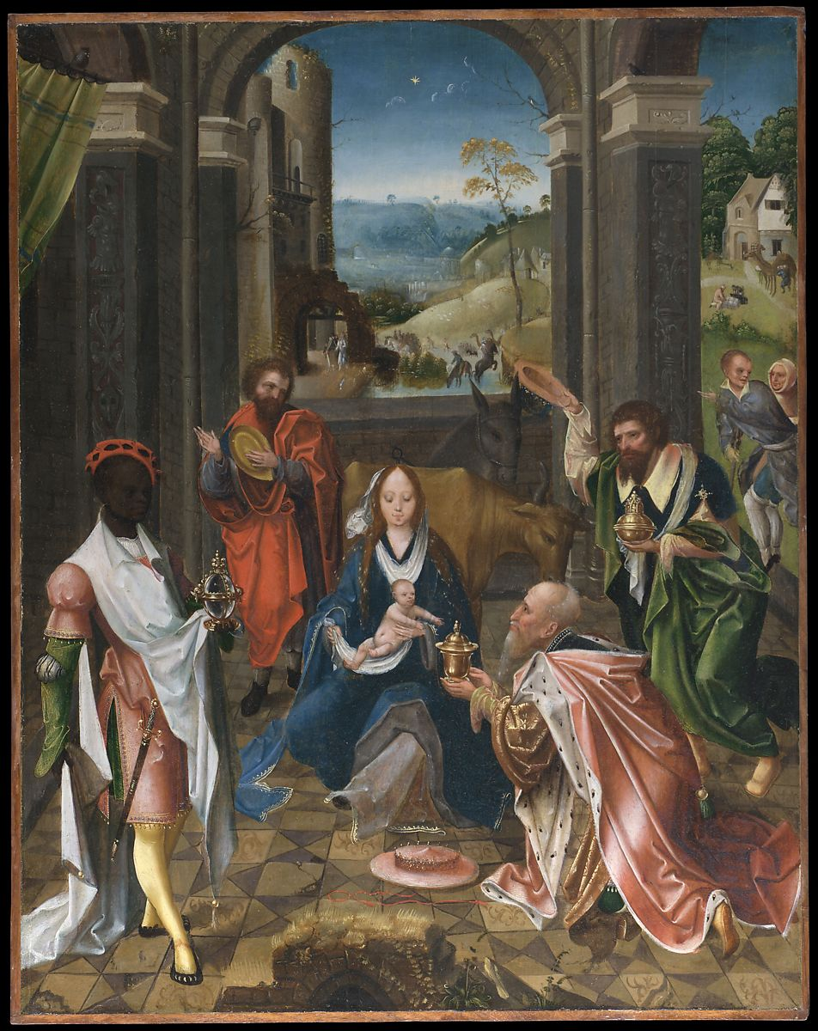

doves shuffle back
and forth on the rafters as though
knowing my water had burst

on the back of the donkey, which looked
around to see whence
the warm June shower

in December. The unappeasable pain
on spikey schedule, while
Joseph cobbles dirty

straw from the stable corners
to make a bed; my birth
stool a broken feed box.
The Adoration of the Magi, Netherlandish (Antwerp Mannerist) Painter
I push the child into his
knobby hands as the stable
door creaks and three

oriental potentates kneel
before the bawling baby --
the placenta on the ground.-- They bring

gifts on dromedaries over
Arabian sands, laying
gold, frankincense and myrrh

at our feet, while I need a basin
of hot water, clean
towels, and piles of diapers.

Kilian McDonnell, OSB

Had We Been There

Into the stable they straggled, poor and dirty,
hardly suitably dressed for polite society.
Had we been Joseph
we would have feared robbery.
Had we been Mary
we would have feared germs around our newborn.
Had we been God
these are not the ones we would have chosen
to first come and see the Child.
After all, they showed a certain carelessness
about the rules of the church.
And yet, God-chosen, they came
to kneel and worship him
whom we would later call the Good Shepherd.
Perhaps we could brush up on our humbleness.

Ann Weems

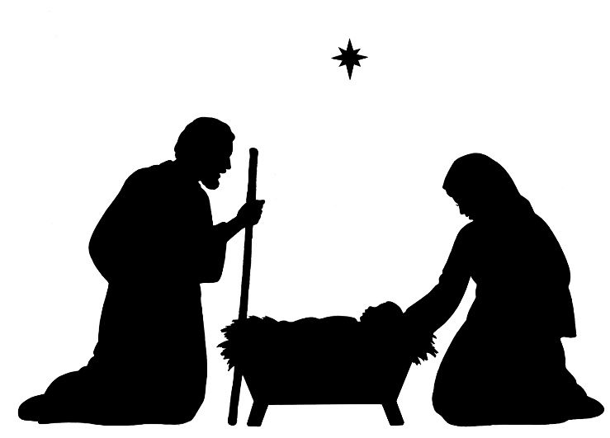
Five Meditations On Mary

1
The Virgin Mary sat on a rock that was not wholly rock
in a world that was not wholly world

in a light that was Light direct
in the echo of a Command that came from God direct

whose womb was now to house a halo more than she could
possibly long for

and which made her fear
and caused her angel messenger to comfort her

as he stood at the door and mentioned how
God had designated her the hallowed hall for His pure breath to enter

to make a child with no seed but Himself
to show mankind His holy fatherhood over all

within the physical
but without physical union
2
The pen is hardly lifted

The penalty for birth is death

But he who would be born without coitus
would slide out of death without its mortal coil

Would be taken up to God without entering death’s womb
as he had entered Mary’s womb without birth’s usual folderol

She clutched a tree to steady herself
and dates fell to the ground around her

And he spoke to her from herself
to steady her

Rings of tumult sang around her
The Garden’s tree was now there to strengthen her

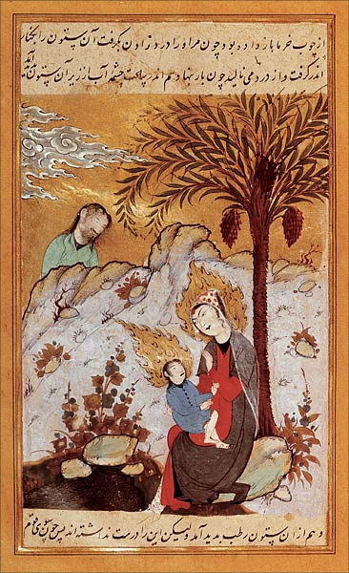
Persian miniature of Mary & Isa (Jesus)

her nearing it part of God’s ordained structure
to redeem Adam and Eve’s descent to earth

by new prophecy through standing under
the virgin birth-tree’s sacred agency

Adam of no visible parents
Eve of no mother but father Adam’s rib-side

being both mother and father
now terrestrialized again in Mary’s husbandless pregnancy

though all of us are actually children
of much more than our mere mother’s earthly sympathy
3
I saw Mary board a bus at Broad and State
her head covered and her face radiant

small and held within herself
careful and preoccupied
a heaven seeming to be wrapped around her
her cheeks red her lips dry her eyes lowered

interior moisture her preferred cloister
the bus passengers sudden ghosts before her

her shoes small and tattered
her hands carrying a book

If any had spoken to her she might have become lost

If she had spoken to anyone
they might have become saved
4
None can be “Mother of God” but God

nor Creator of us but God Himself

Jesus begat in light sat in light and was transformed into light
beyond light’s shapes of dark and light

his salutation from where he is continues to excite us
just as Mary’s humility brings us home

to where impossible things are true
and true things impossible or possible by our own lights

to submit as purely to God’s sheer command of: Be!

more than enough to be
in Being’s age-long mystery

5

In Ephesus is Artemis
with multitudes of breasts
and legend says where Mary went
and where she died and rests

Teets our forms are fed from
virgin light that salves our souls
the two eternal females
through whom our life unrolls

The Virgin ever virginal
in modesty extreme
and Artemis whose many breasts
supply an endless stream

One statue standing among rocks
the other in her cave
whose house of stone is all alone
within the Light we crave

Daniel Abdal-Hayy Moore

An Old Woman Remembers (The Flight into Egypt)

When dark clouds cover moon’s
craters we push open creaky stable
doors, lead the donkey out to leave
for Egypt before Herod’s
soldiers pound upon gate. We hear

Rachels screaming, sons slaughtered
by decree, while we angle across
plowed barley fields, like robbers
with sagging bags of silver drachmas,
always looking back, avoiding

roads. Stadia and stadia later
we hear uncertain night noises
of distant battles, lost and won:
an ox bellowing, and the hissing
of ten skin-headed vultures

as they claw and squabble over a dead
sheep. We pass on the far side.
After two weeks off Gaza roads
we’ve not crossed the border, but far
enough to rest a day beside a huge
abandoned columbarium, rebels’ lair,
filled with white bird droppings,
and coppery green pigeon feathers.
To rest the donkey Joseph stops
beneath a turpentine tree while my infant

wails, wet diaper full once
more. On a flat rock I change
him, give him my nipple. He’s
beautiful beyond all imagining.
In thorn bushes Joseph finds a nest

of sand colored eggs, enough to get us
to the Nile. What cobra-crowned
Ramses reigns as Son of sun-
god Re, demanding bricks,
withholding straw, and knows not Joseph?

Kilian McDonnell, OSB

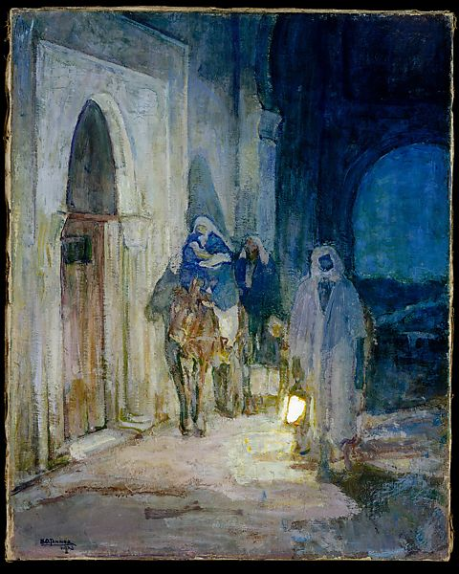
The Flight into Egypt, Henry Ossawa Tanner

The Refugees

Into the wild and painful cold of the starless winter night
came the refugees,
slowly making their way to the border.
The man, stooped from age or anxiety,
hurried his small family through the wind.
Bearded and dark, his skin rough and cracked from the cold,
his frame looming large in spite of the slumped shoulders:
He looked like a man who could take care of whatever
came at them
from the dark.
Unless, of course, there were too many of them.
One man he could handle . . . two, even
. . .
but a border patrol . . .
they wouldn’t have a chance.
His eyes, black and alert,
darted from side to side, then over his shoulder,
then back again forward.
Had they been seen?
Had they been heard?
Every rustle of wind, every sigh from the child,
sent terror through his chest.
Was this the way?
Even the stars had been unkind –
had hidden themselves in the ink of night
so that the man could not read their way.
Only the wind . . . was it enough?
Only the wind and his innate sense of direction . . .
What kind of a cruel judgement would that be,
to wander in circles through the night?
Or to safely make their way to the border
only to find the authorities waiting for them?

He glanced at the young woman, his bride.
No more than a child herself,
she nuzzled their newborn, kissing his neck.
She looked up, caught his eye, and smiled.
Oh, how the homelessness had taken its toll on her!
Her eyes were red, her young face lined,
her lovely hair matted from inattention,
her clothes stained from milk and baby,
her hands chapped from the raw wind of winter.
She’d hardly had time to recover from childbirth
when word had come that there were hunted,
and they fled with only a little bread,
the remaining wine,
and a very small portion of cheese.
Suddenly, the child began to make sharp noises.
The man drew his breath in sharply;
the woman quietly put the child to breast.
Fear . . . long dread-filled moments . . .
Huddles, the family stood still in the long silence.
At last the man breathed deeply again,
reassured they had not been heard.
And into the night continued
Mary, Joseph and the Babe.

Ann Weems

A Blesséd Embarrassment

Mary is a blessed embarrassment
to a harassed world

for she is great in more ways than one
and we wonder how she managed

to contain the salvific secret
seeing all that she had seen and heard.

How absurd, say all the knowing,
unknown as we are to such magnificence.

What guidance, what star, what manger
can cradle our indifference?

An offense against our apathy
this pathetic refugee mother.

But what other birth will ever be able
to make us strong and stable with shalom –

home again in the world God made.
Home with Mary’s – and Joseph’s – aid.

Thomas John Carlisle

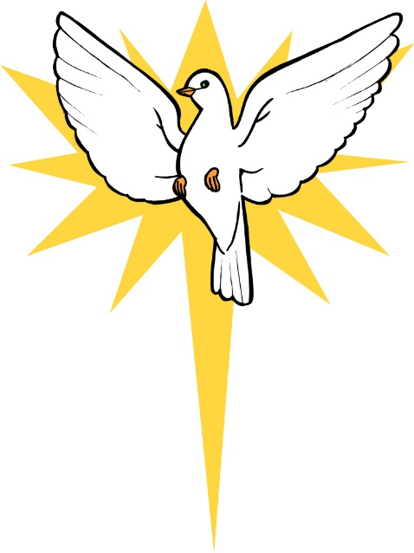

The Body is Like Mary

The body is like Mary, and each of us has a Jesus inside.
Who is not in labour, holy labour? Every creature is.

See the value of true art, when the earth or a soul is in
the mood to create beauty;

for the witness might then for a moment know, beyond
any doubt, God is really there within,

so innocently drawing life from us with Her umbilical
universe – infinite existence …

though also needing to be born. Yes, God also needs
to be born!

Birth from a hand’s loving touch. Birth from a song,
from a dance, breathing life into this world.

The body is like Mary, and each of us, each of us has
a Christ within.

Mevlana Jalaluddin Rumi (translated by Daniel Ladinsky)

From Three Songs of Mary

- O Oriens

O come, O come Emmanuel
within this fragile vessel here to dwell.
O Child conceived by heaven’s power
give me thy strength: it is the hour.

O come, thou Wisdom from on high;
like any babe at life you cry;
for me, like any mother, birth
was hard, O light of earth.

O come, O come, thou Lord of might,
whose birth came hastily at night,
born in a stable, in blood and pain
is this the king who comes to reign?

O come, thou Rod of Jesse’s stem,
the stars will be thy diadem.
How can the infinite finite be?
Why choose, child, to be born of me?

O come, thou key of David, come,
open the door to my heart-home.
I cannot love thee as a king –
so fragile and so small a thing.

O come, thou Day-spring from on high:
I saw the signs that marked the sky.
I heard the beat of angels’ wings
I saw the shepherds and the kings.

O come, Desire of nations, be
simply a human child to me.
Let me not weep that you are born.
The night is gone. Now gleams the morn.

Rejoice, rejoice, Emmanuel,
God’s Son, God’s Self, with us to dwell.

Madeleine L’Engle

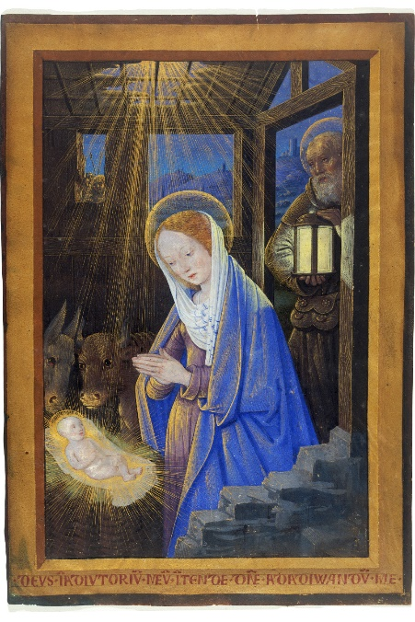
Nativity from The Book of Hours of Louis XII, Jean Bourdichon

Sources
Bozarth, The Rev. Dr. Alla Renée in Women’s Uncommon Prayers: Our Lives Revealed, Nurtured, Celebrated; Elizabeth Geitz, Marjorie A. Burke, and Ann Smith, ed. Harrisburg, PA, Morehouse Publishing, 2000, pp. 287-288.

Carlisle, Thomas John Carlisle. Beginning with Mary: Women of the Gospels in Portrait. Grand Rapids, MI., William B. Eerdmans Publishing Company, 1986; pp. 2, 3, 6.

Donne, John. “University of Dayton: All About Mary.” Online. 11/6/20019. <https://udayton.edu/imri/mary/p/poems-by-john-donne.php

Kenyon, Jane in Watch for the Light: Readings for Advent and Christmas; Maryknoll, New York, Orbis Books, 2004, pp. 118-119.

L’Engle, Madeleine. The Ordering of Love: The New & Collected Poems of Madeleine L’Engle. Colorado Springs, CO., Waterbrook Press, 2005; pp. 153, 231-233, 236–240.

McDonnell, Kilian. “University of Dayton: All About Mary.” Online. 11/6/20019 <https://udayton.edu/imri/mary/p/poems-by-kilian-mcdonnell.php>

Merton, Thomas. “University of Dayton: All About Mary.” Online. 11/6/2019. <https://udayton.edu/imri/mary/p/poems-by-thomas-merton.php>

Moore, Daniel Abdal-Hayy. “The Ecstatic Exchange.” Online. 2007. 11/4/2019. <https://www.ecstaticxchange.com/2012/12/25/poem-five-short-meditations-on-the-virgin-mary/>

Norris, Kathleen, Journey: New and Selected Poems 1969-1999. Pittsburgh, PA., University of Pittsburgh Press, 2001; pp. 85, 96.

Rumi, Mevlana Jalaluddin (translation by Daniel Landinsky). “sufispirit.” Online. 11/4/2019. <http://sufispirit.com.au/feature/rumi-sufi-poetry-body-like-mary/>

Weems, Ann. Kneeling in Bethlehem: Poetry for Advent and Christmas. Louisville, KY., Westminster John Knox Press, 2010; pp. 25, 59-60.

Winter, Miriam Therese. WomanWord: A Feminist Lectionary and Psalter – Women of the New Testament. New York, New York, Crossword Publishing Co., 1992, p. 15.

Illustrations

Dec. 2: Detail of Mary from Fresco,. Monastery Gracanica, Serbia, 1318-1320

Dec. 4: Virgin in Cloud of Angels with Saints Barbara & Catherine, The Porcher Hours, 1500; J. Paul Getty Museum, Los Angeles

Dec. 5: Annunciation Triptych (center panel), Mérode Altarpiece, workshop of Robert Campin, 1427-1432, Metropolitan Museum of Art

Dec. 7: Annunciation, Giovanni Bellini, ca. 1500, Gallery of Accademia, Venice

Dec. 9: Annunciation, Henry Ossawa Tanner, 1898, Philadelphia Museum of Art

Dec. 11: Annunciation (detail), Simone Martini & Lippo Memmi, 1333, Uffizi Gallery, Florence, Italy

Dec. 12: The Windsock Visitation, Mickey McGrath, OSFS, 1995, Visitation Monastery of Minneapolis

Dec. 13: Le magnificat, James Tissot, 1886-94, Brooklyn Museum.
.
Dec. 14: Mary’s Song, Julie Lonneman, 2008. Online
<http://julielonneman.blogspot.com/2008/12/marys-song_20.html>

Dec. 15: Behold the Lamb of God, Walter Rane. Online <https://www.churchofjesuschrist.org/media-library/images/walter-rane-nativity-183368?lang=eng>

Dec. 16: Nativité, Maurice Denis, 1894, Musée des St. Augustins, Toulouse, France

Dec. 17: The Adoration of the Magi, ca. 1520, Netherlandish (Antwerp Mannerist) Painter, Metropolitan Museum of Art

Dec. 19: Persian miniature of Mary and Isa (Jesus), prior to 20th century

Dec. 20: The Flight into Egypt, Henry Ossawa Tanner, 1923, Metropolitan Museum of Art

Dec. 24: Nativity from The Book of Hours of Louis XII, 1499, Jean Bourdichon

